Fatima Tariq

FA24-BBA-021-A

Programming

# Quiz no1

Question no 1:

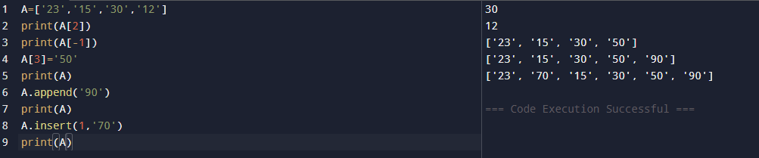

Question no 2:

